[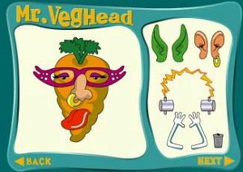](http://www.safekidgames.com/games/veghead.html)

[Mr VegHead](http://www.safekidgames.com/games/veghead.html" \t "_blank)

[](http://monarchcenters.wikispaces.com/bubblewrap)

[Bubble wrap](http://monarchcenters.wikispaces.com/bubblewrap" \t "_blank)

[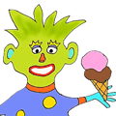](http://www.ziggityzoom.com/onlinegames.php?game=feed-the-monster)

[Feed The monster](http://www.ziggityzoom.com/onlinegames.php?game=feed-the-monster" \t "_blank)

[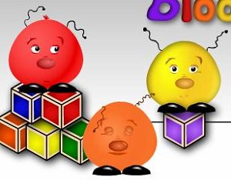](http://www.sheppardsoftware.com/preschool/ngames/colors.htm)

[Boople’s Colors](http://www.sheppardsoftware.com/preschool/ngames/colors.htm" \t "_blank)

[](http://www.tvokids.com/games/animalwho)

[Type a letter](http://www.tvokids.com/games/animalwho" \t "_blank)

[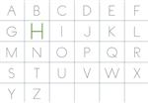](http://www.literacycenter.net/letters_en/typing_en_uc.php)

[Type the Alphabet](http://www.literacycenter.net/letters_en/typing_en_uc.php" \t "_blank)

[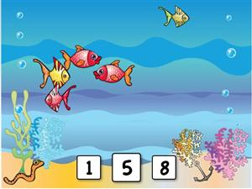](http://www.abcya.com/counting_fish.htm)

[Counting Fish](http://www.abcya.com/counting_fish.htm" \t "_blank)

[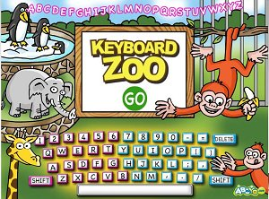](http://www.abcya.com/keyboarding_practice.htm)

[Keyboard Zoo](http://www.abcya.com/keyboarding_practice.htm" \t "_blank)

[Bubble Letters](http://www.letterbubbles.com/" \t "_blank)

[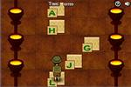](http://www.learninggamesforkids.com/keyboarding_games/keyboarding_games_typing_adventure1.html)  
[Typing Adventure 1](http://www.learninggamesforkids.com/keyboarding_games/keyboarding_games_typing_adventure1.html" \t "_blank)

[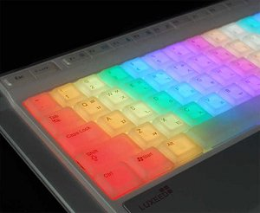](http://www.bigbrownbear.co.uk/keyboard/index.htm)

[Keyboard Typer](http://www.bigbrownbear.co.uk/keyboard/index.htm" \t "_blank)

[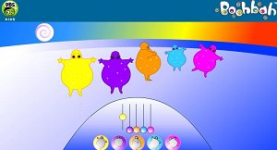](http://danryckert.eu/)

[BoohBah](http://www.boohbah.tv/zone.html" \t "_blank)

[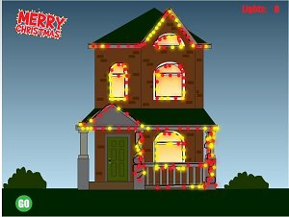](http://www.abcya.com/kindergarten_christmas_lights.htm)

[Holiday lights](http://www.abcya.com/kindergarten_christmas_lights.htm" \t "_blank)

[](http://www.abcya.com/pumpkin_carving.htm)

[Carve a Pumpkin](http://www.abcya.com/pumpkin_carving.htm" \t "_blank)

[](http://www.abcya.com/christmas_tree.htm)

[make a tree](http://www.abcya.com/christmas_tree.htm" \t "_blank)

[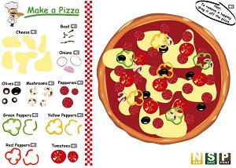](http://www.abcya.com/pizza.htm)

[make a pizza](http://www.abcya.com/pizza.htm" \t "_blank)

[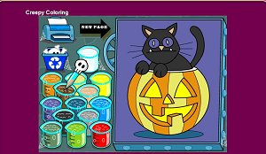](http://www.roundgames.com/game/Creepy+Coloring)

[Creepy Coloring](http://www.roundgames.com/game/Creepy+Coloring" \t "_blank)

[ype rocket ](http://www.abcya.com/typing_rocket.htm)

[Type Rocket Jr](http://www.abcya.com/typing_rocket.htm" \t "_blank)

[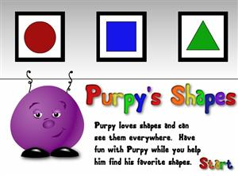](http://www.sheppardsoftware.com/preschool/ngames/shapes.htm)

[Purpy's   
Shapes](http://www.sheppardsoftware.com/preschool/ngames/shapes.htm" \t "_blank)